Project Report

Pan Zewen(19083967d)

Tian Ruijie(19079692d)

Wang Xiangzhi(19082878d)

Wang Zhe(19080037d)

Zhang Xianyi(19078513d)

## Introduction

## 1.1 Aims

This project builds an automated examination system allowing teachers to create and students to take exams more conveniently. In this system, teachers can create an exam paper by logging in to the system and selecting the “Test Designer” option. Then teacher should decide the elements, after teacher has chosen all the elements an exam needs, student can sit the paper by logging in to the system. During the test, a student would know how much time left (A timer will be shown on the GUI for student to refer). After the teacher’s manual grading and the automatic grading by the system using the set correct answer, students will know their score on the system. In addition, test results for students are kept for ten years. By the way, teacher should generate a report for student to refer.

## 1.2 Project Overview

At first, we have finished the ER diagram which defines all necessary entities including teacher, exam etc. and the relationship among them. Then implementing codes to make these happen. For the code part, we have split it into different parts by the language we use and the pattern of them. We use Python to generate random data (testing data), use MySQL to create table and insert, update, delete, access data in the table, use java to build the front-end part of the Examination System including “model”, “controller”, “view” (MVC Pattern).

## 1.3 Report Overview

In this report, we describe the structure of the Automated Examination System and how we build it in detail in the second part, also the challenges we have faced. The third part is user guide to instruct users to conveniently use this Automated Examination System. The fourth part is analysis reports which can generate reports from the database to analyze the performance of students in different subjects. The final part describes the contributions each of us made.

## Design

## 2.1 Entities and Attributes

## 2.1.1 ER Diagram

This ER (Entity Relationship) Diagram represents the model of Automated Examination System Entity. The ER Diagram shows all the tables created and the relations between Class, Exam, Student, Teacher etc. The main entities of the Automated Examination System are Class, Student, Exam, Subject, Teacher, Question, Record/Result and Answer.

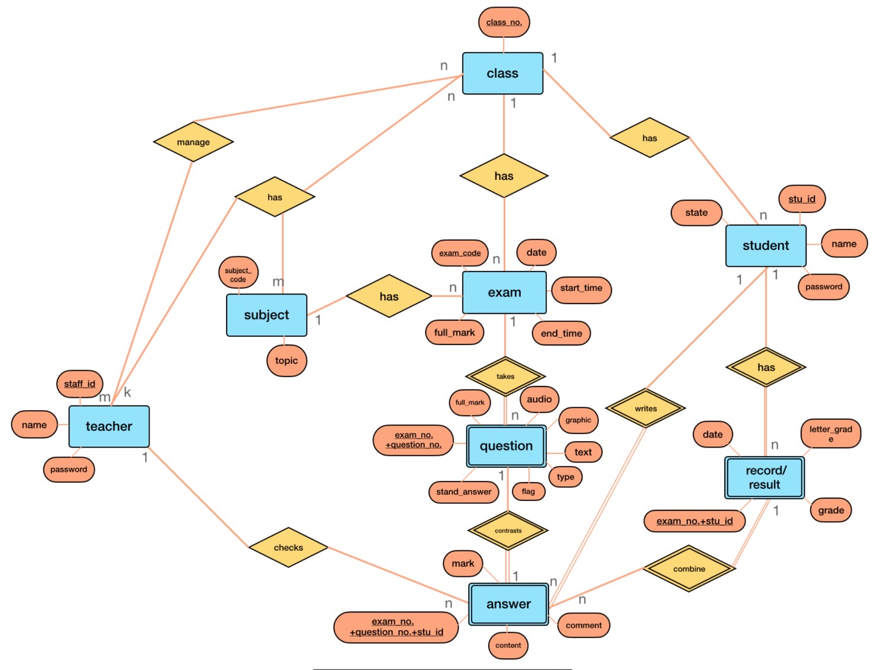

## 2.1.2 Automated Examination System entities, relations and their attributes

Teacher (staff_id, name, password)

Teach (staff_id, subject_code)

Subject (subject_code, topic)

Deliver (class_no., staff_id)

Class (class_no., staff_id,exam_code, subject_code)

Has (staff_id, subject_code)

Question (exam_code, question_no., standard_answer, full_mark, flag, type, text, audio, graphic)

Exam (exam_code, date, start_time, due_time, full_mark, subject_code)

Answer (stu_id,exam_code, question_no., content,mark, comment)

Student (stu_id, name, password, state, class_no.)

## 2.1.3 Relational Schema model

The Relational Schema model shows the relation between all the entities based on the given Automated Examination System entities, relations and their attributes.

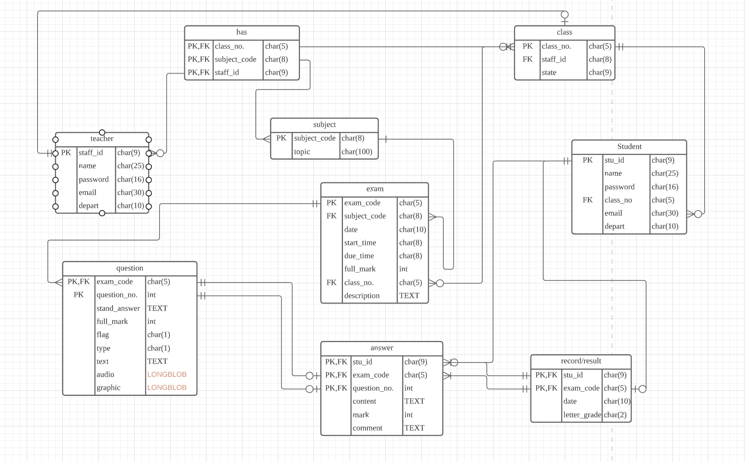

## 2.2 Implementation

## 2.2.1 Main Structure

**Java**

We used MVC Pattern as requested. Therefore, there are 3 main classes used, and we also use 3 different kinds of enums.

**1.View**

Class View contains functions as below.

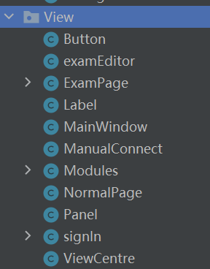

These functions together combine the interface of the Automated Examination System. After setting all the parameters of page-size, button-size and characters etc., the final main page, exam page and information page are as below.

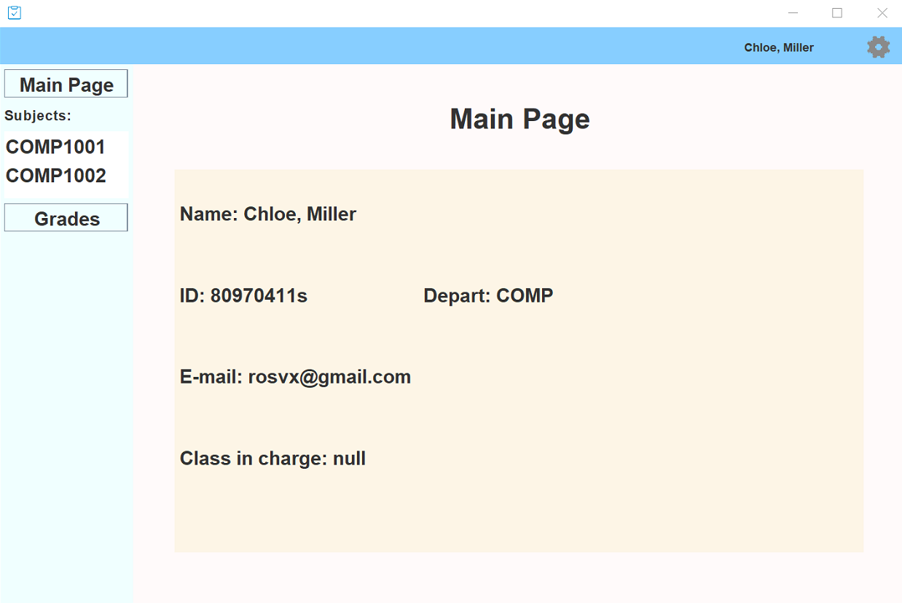

Exam page of teacher:

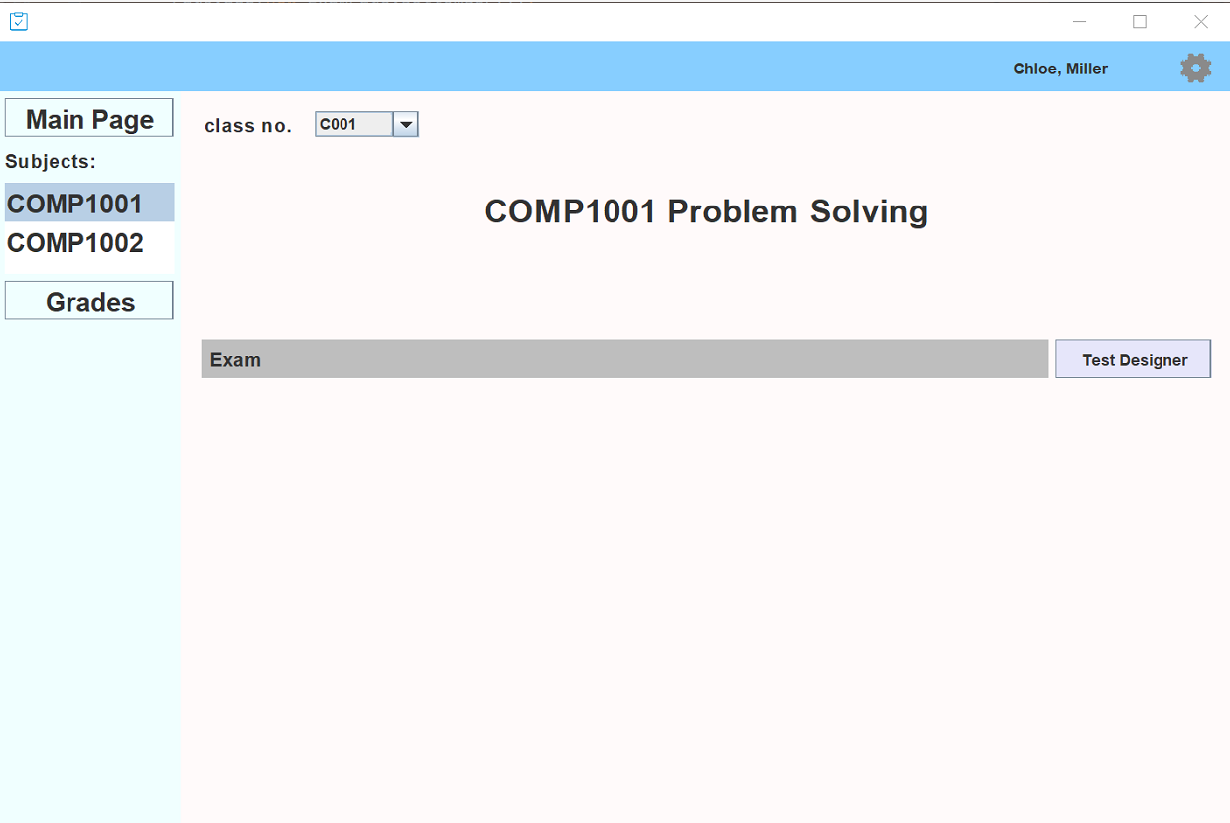

Exam page of students:

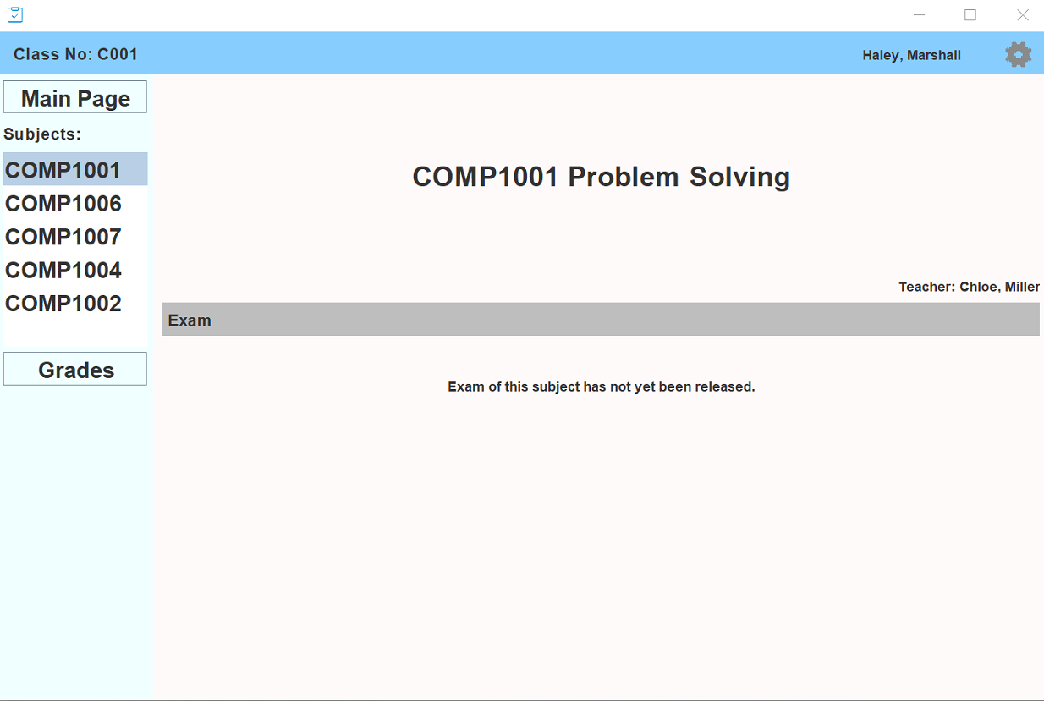

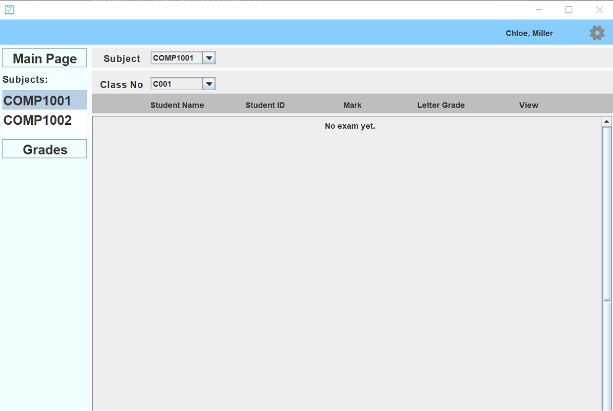

## 2.2.2 Controller



In addition to the View, there needs a control center to help with the total control, and user could run this program via AESController, the main method is written in this class.

## 2.2.3 Model

As for models we have Answer, Attribute, Classroom, Connection, designer, Entity, Exam, Pack, Question, QuestionType, Record, Student, StuSignIn, Subject, Teacher and TeaSignIn.

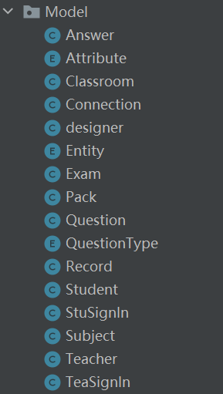

These classes are used to:

1) get a specific type of data out of the database,

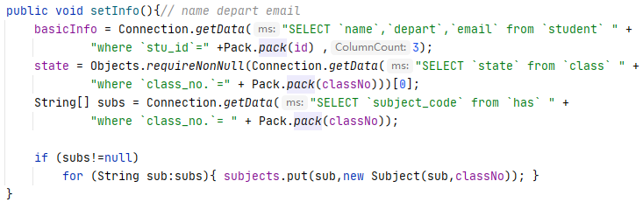

2) store the data that the system gets out of the database,

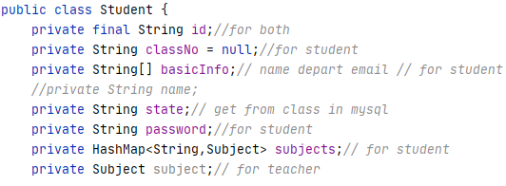

3) provide data to the view components to implement human-computer interaction (picture below shows how Exam Page get exam data by calling “getQuestions()” methods, then add then to the page panel).

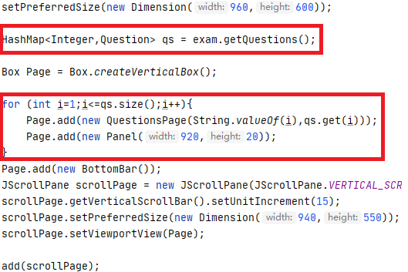

4) in the form of Enums, to store all constant values that would be used.

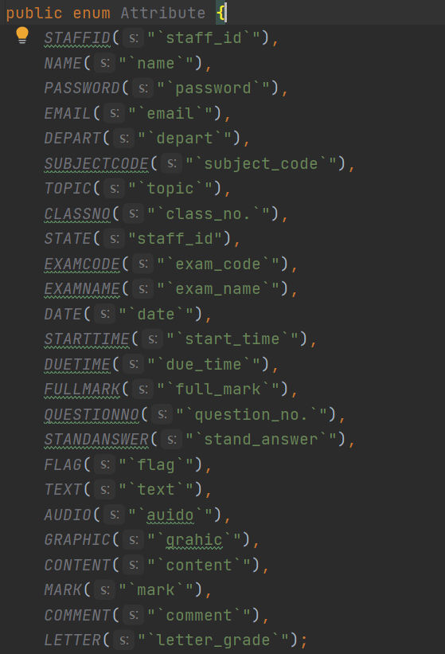

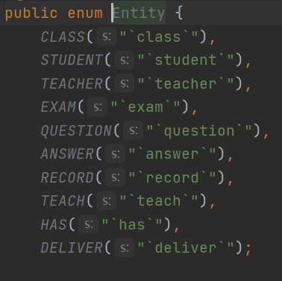

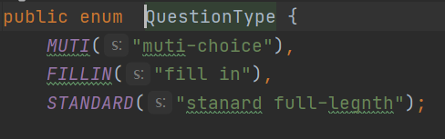

## 2.2.4 Database——MySQL

For the database part, we use MySQL to create the tables and store the data. There are totally 9 SQL files in the SQL part, here we will introduce how it works on by one.

1. Class

INSERT student into class.

1. Create_tables

CREATE all the tables that we need in the whole database system. Such as class, teacher, student, etc. In addition, set the primary key and foreign key of each table to connect them.

1. Drop_tables

Drop the tables that we won’t need to simplify the project work.

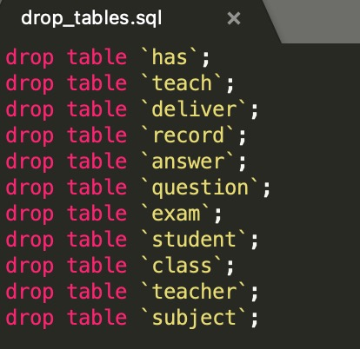

1. Has

Show the tri-nary relationship among teachers, students and classes.

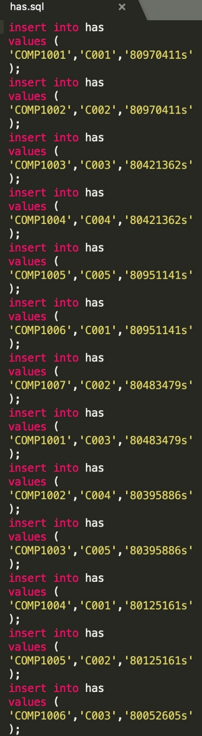

1. Student

INSERT the information of the students.

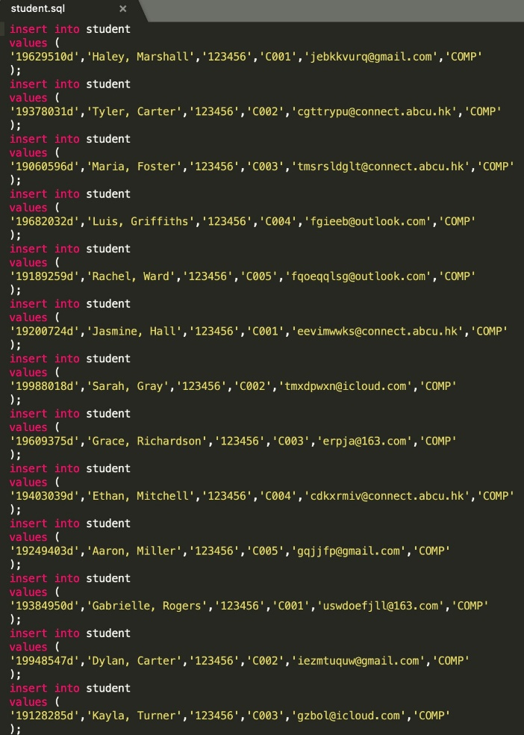

1. Subject

INSERT the information of the subjects

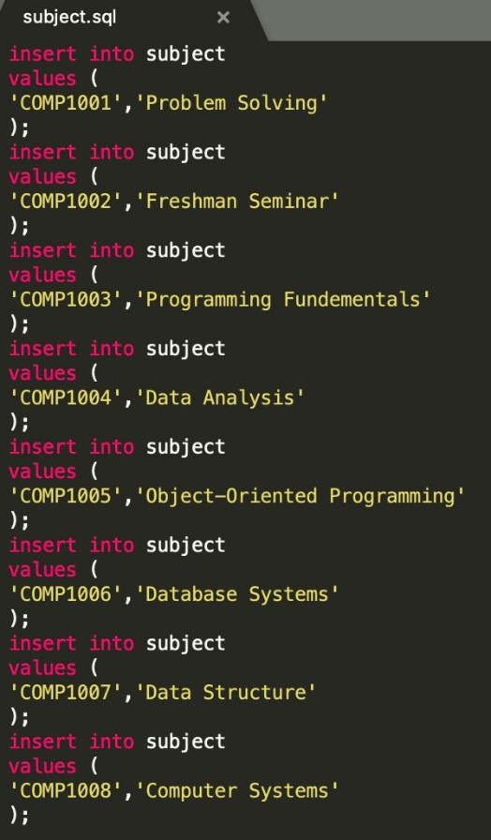

1. Teach

INSERT the teaching information of different subjects.

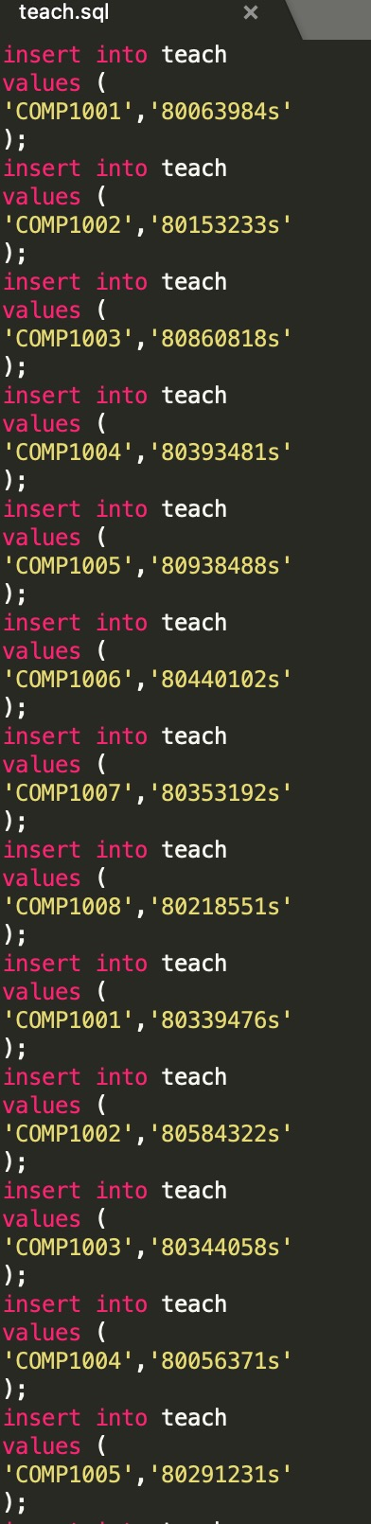

1. Teacher

INSERT the information of the teachers.

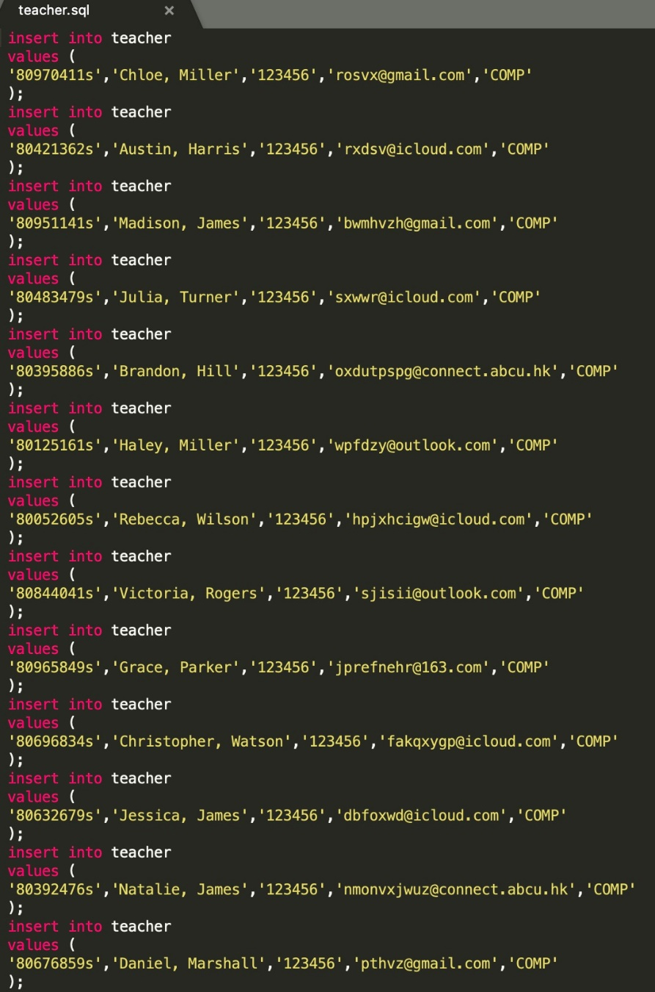

## 2.2.5 Functions

Based on the aims, we have built this Automated Examination System to let it have different functions.

* 1. Connect to database

As taught in the lab, we use the jar package of JDBC driver to connect java program to database.



We use ‘getConnection()’ method to connect MySQL database before doing database input/output.



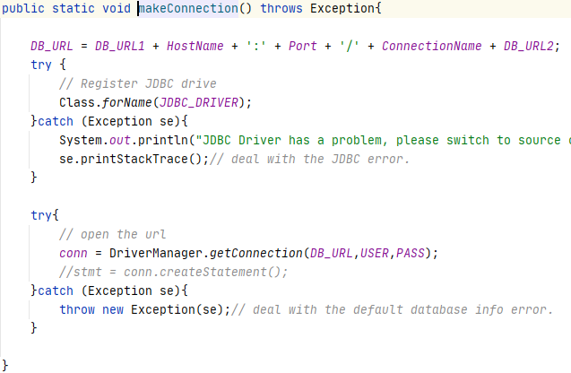

And we use ‘executeQuery()’ method to execute SQL commands.

Note that each time after fetching data from database, we close the connection and reconnect on next fetching. This is because MySQL database would automatically disconnect when being idle for some time. (There’s also another way to handle this, add “autoReconnect = true” after the JDBC’s URL. But it’s sad that we know this too late.)

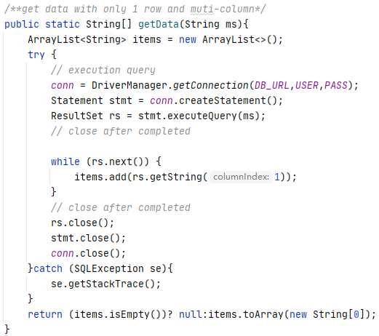

* 1. Login

Once the system has initialized, users (teachers and students) can log on to the system using their id and password (By clicking the “?” on the bottom right corner, user could see the help page (stored locally)).

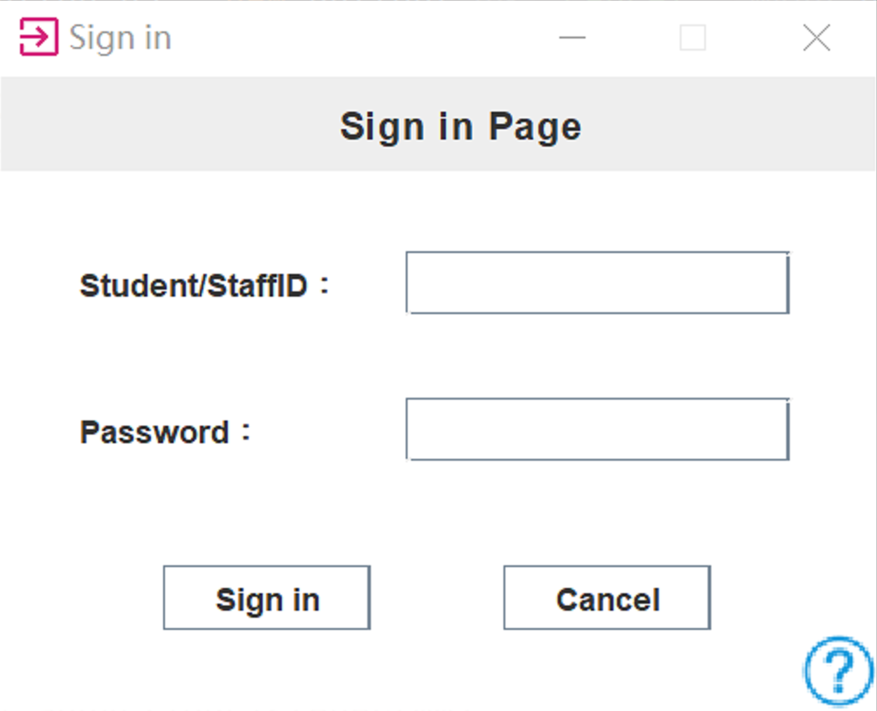

The system will then get the data of the user from “data pool” to verify the identity.

Relevant codes are as below.

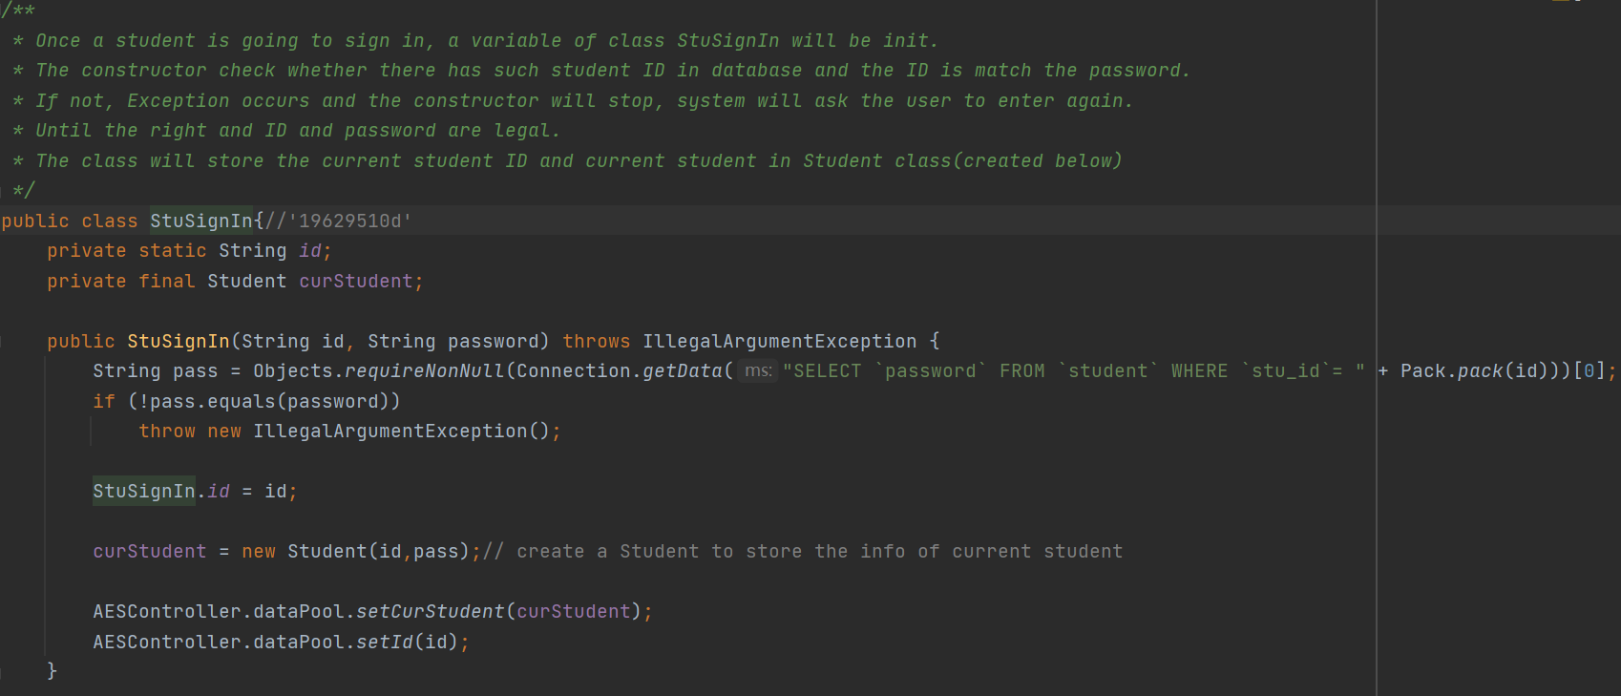

After entering the right user id and passcode, system will show the main page. Users could also come back to this page anytime by clicking the “Main Page” button in the red box)

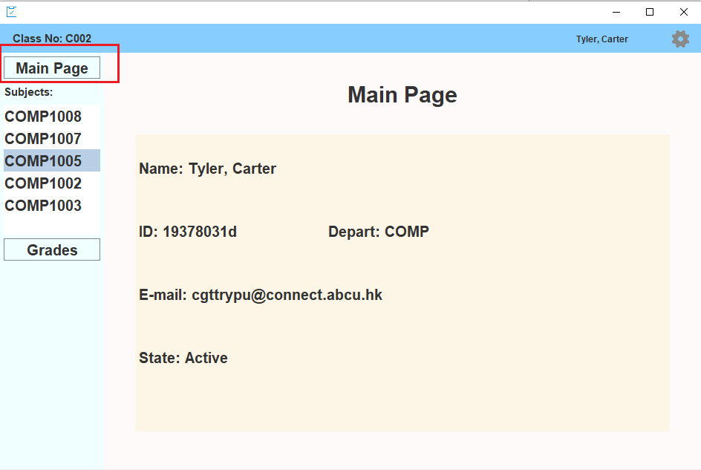

Additional function: By clicking the setting button in the upper right corner, you can change the password of the current login id or sign out from the system.

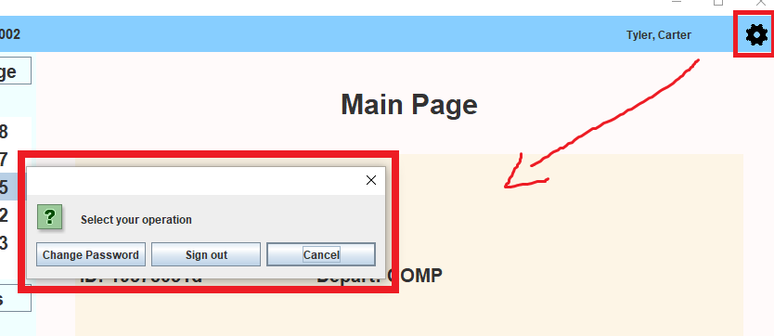

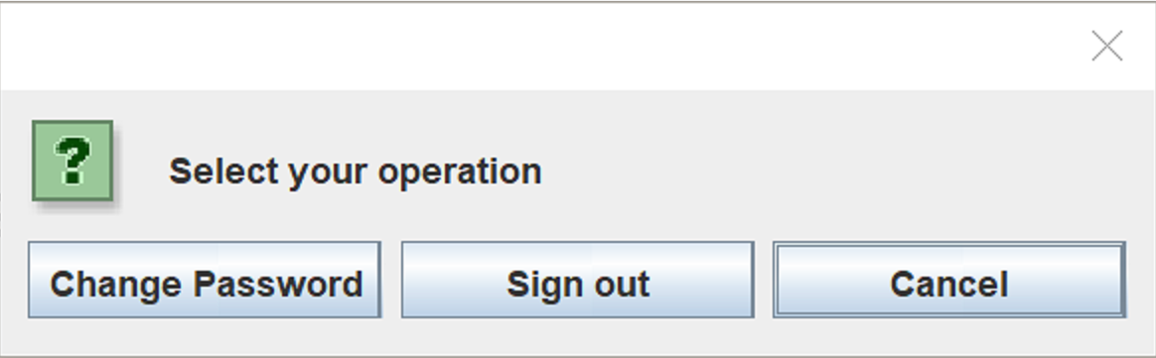

Users can change the password easily after we verify the old password.

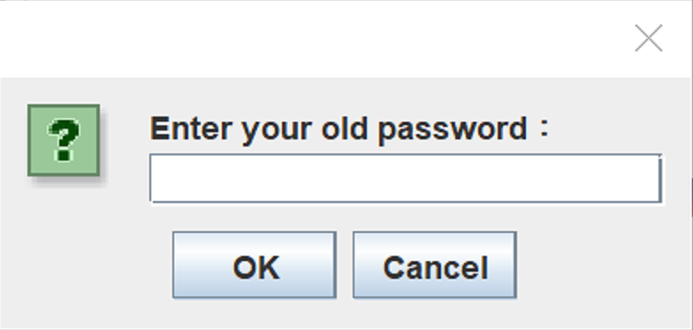

If the wrong old password is entered, there will be a prompt and the user is asked to enter again.

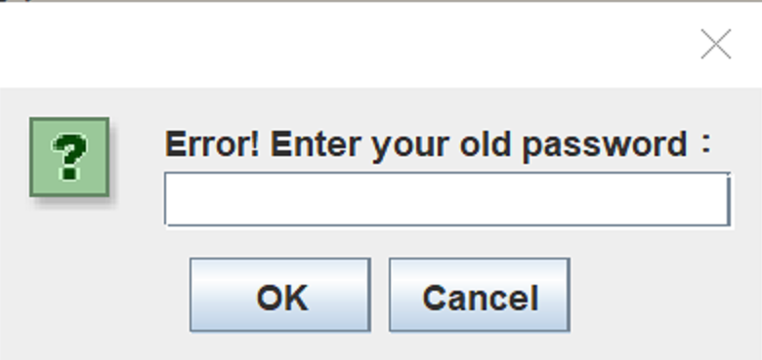

Pictures below show that the user is asked to enter the new password.

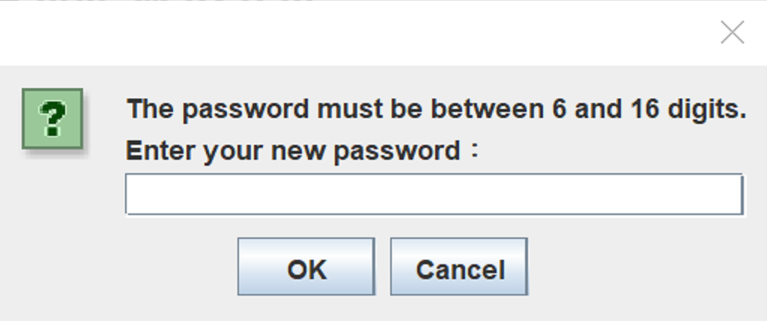

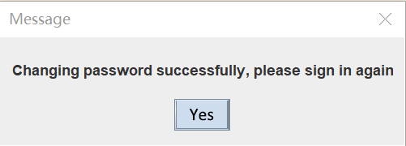

Error condition during this session:

If the input id or password is empty or wrong, system will return:

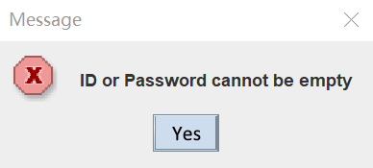

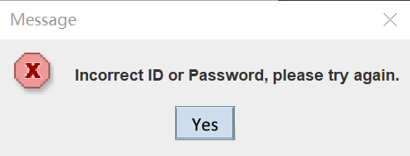

Relevant codes are shown below:

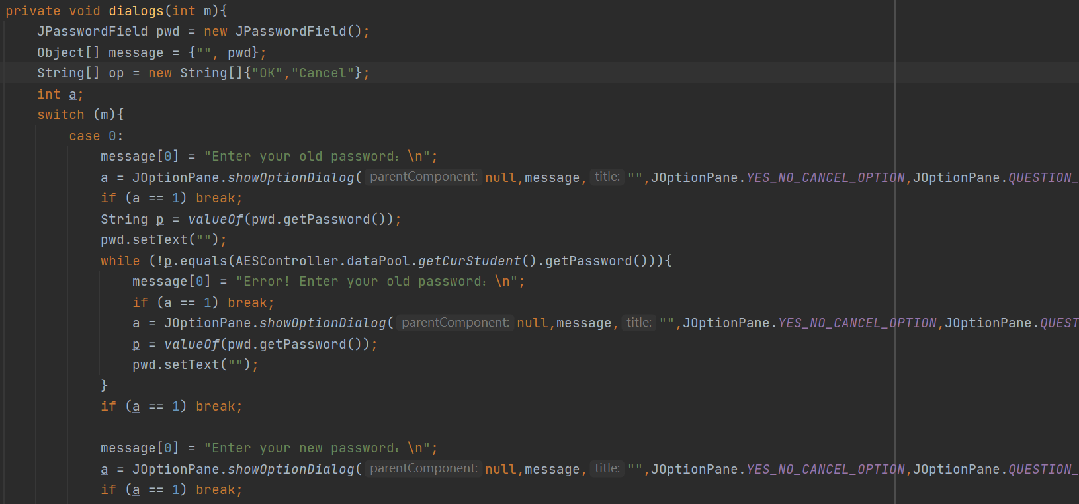

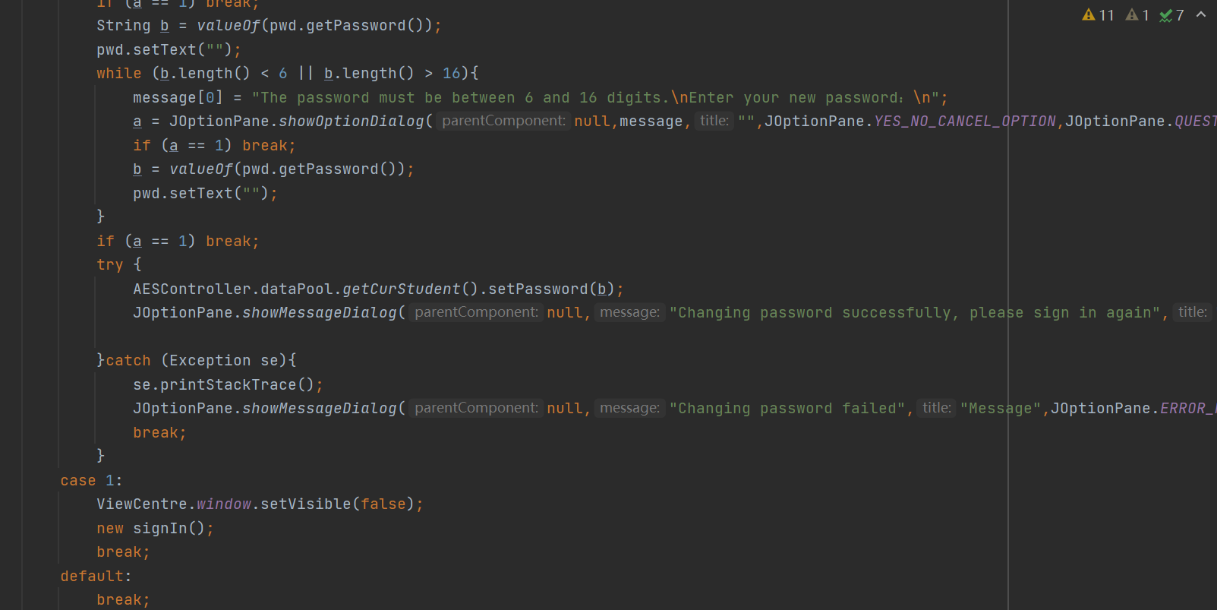

Moreover, if anyone of the host name, port, connection name, user name and password does not match the local database, users will be asked to type manually.

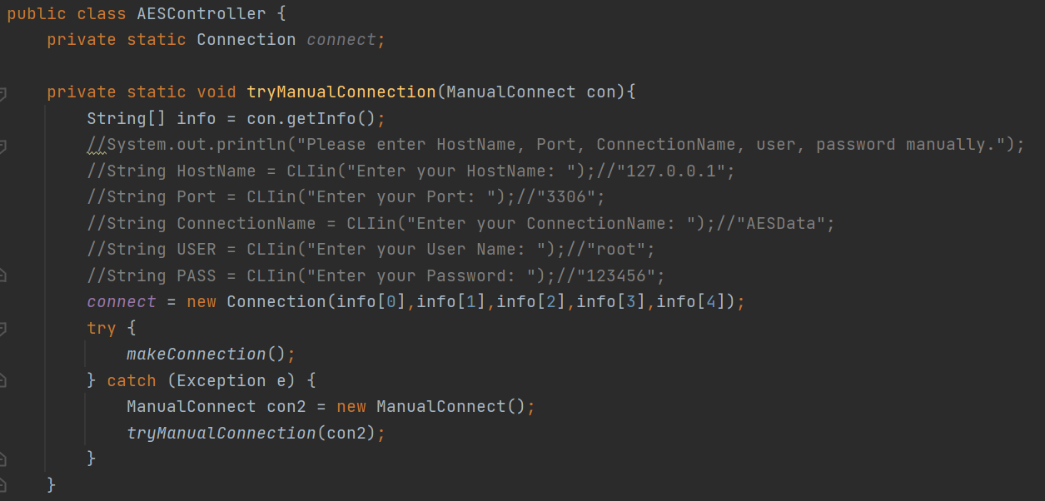

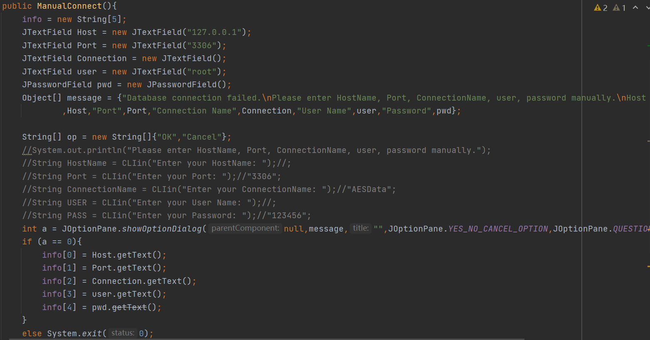

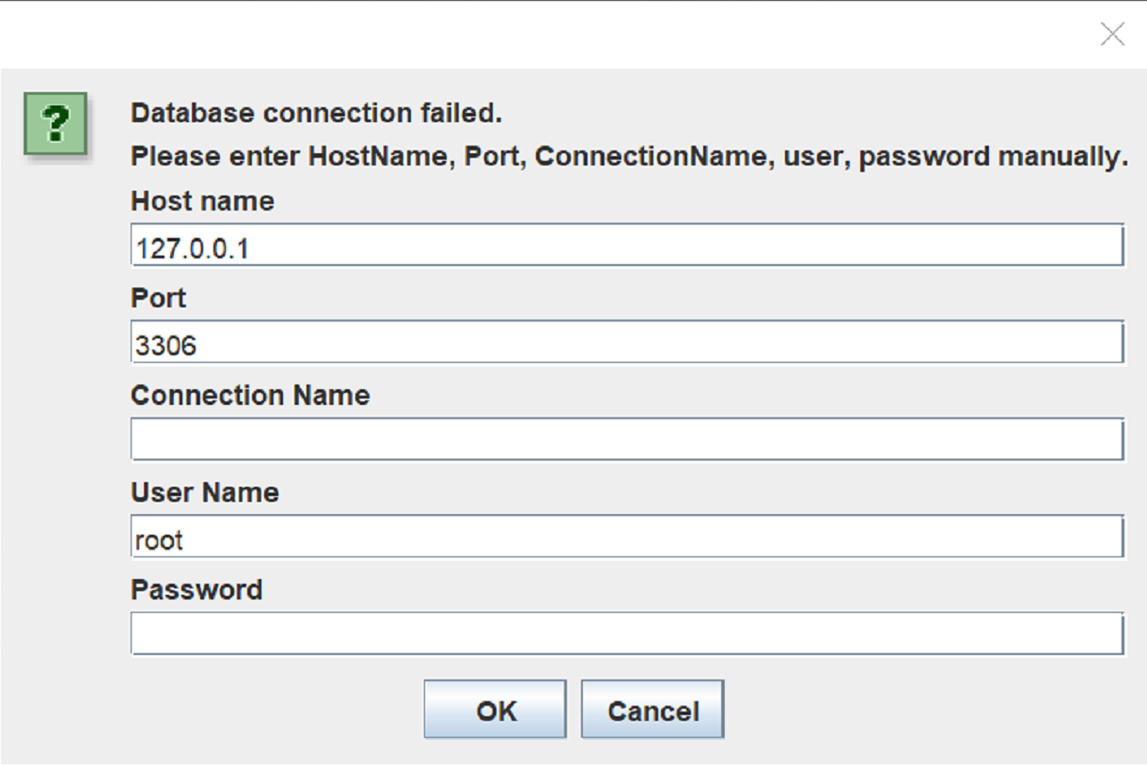

* 1. Test Designer (Teachers Only)

After selecting the “Test Designer” option. Teacher selects the class that the exam is for and the subject and test number.

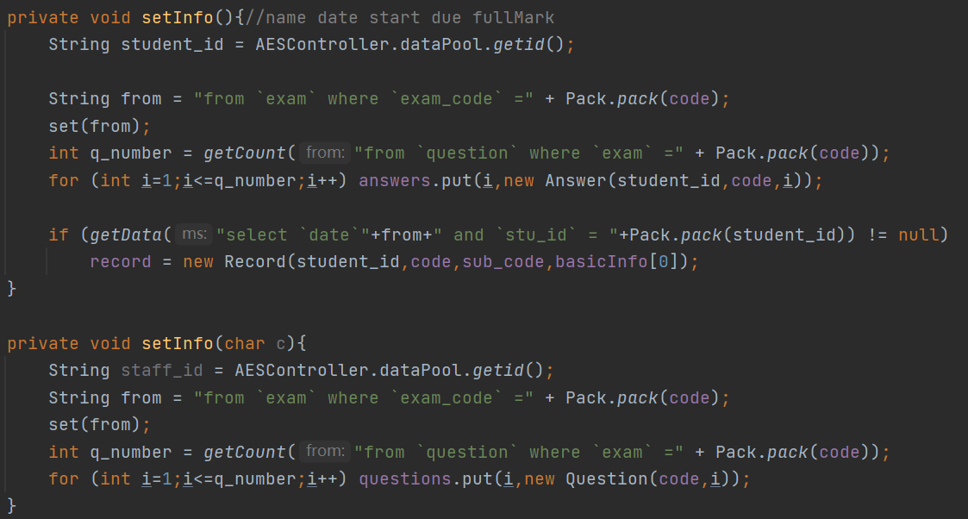

He/She also sets the date, start-time and duration of the exam.

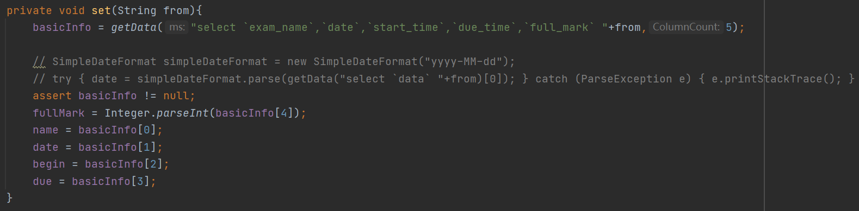

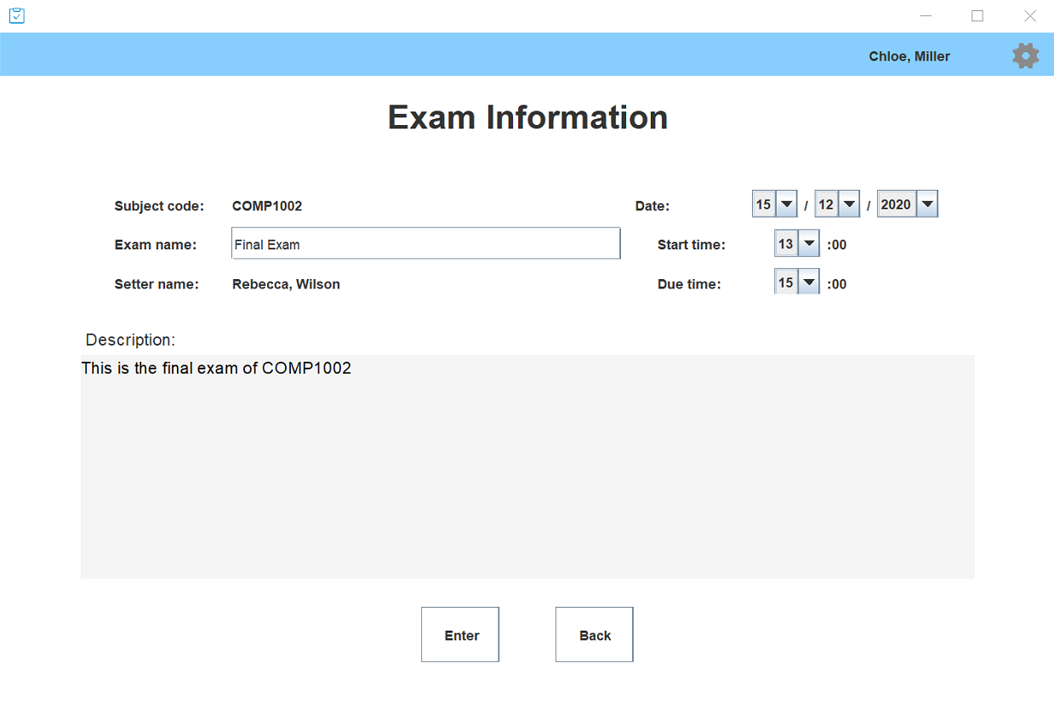

There are three types of questions:

* + - Multiple choice
    - Fill in the blank
    - Standard full-length test questions.

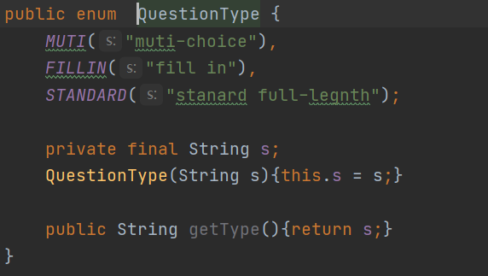

The teacher should enter the question and the correct answers (excluding the standard exam type questions which will be corrected manually on-screen in a batch). Below are the sample questions one teacher made.

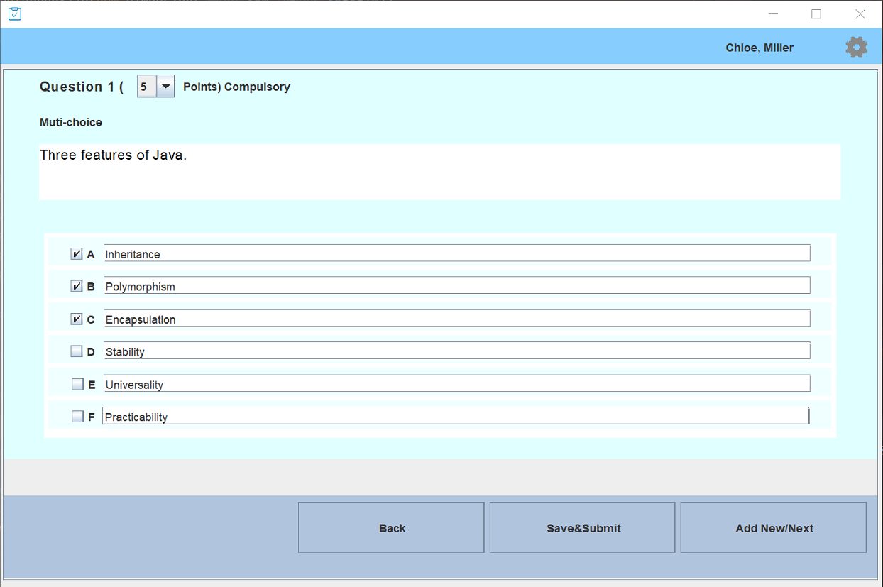

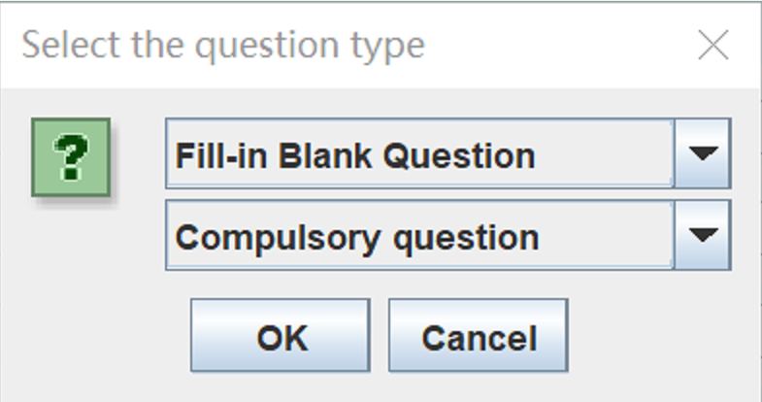

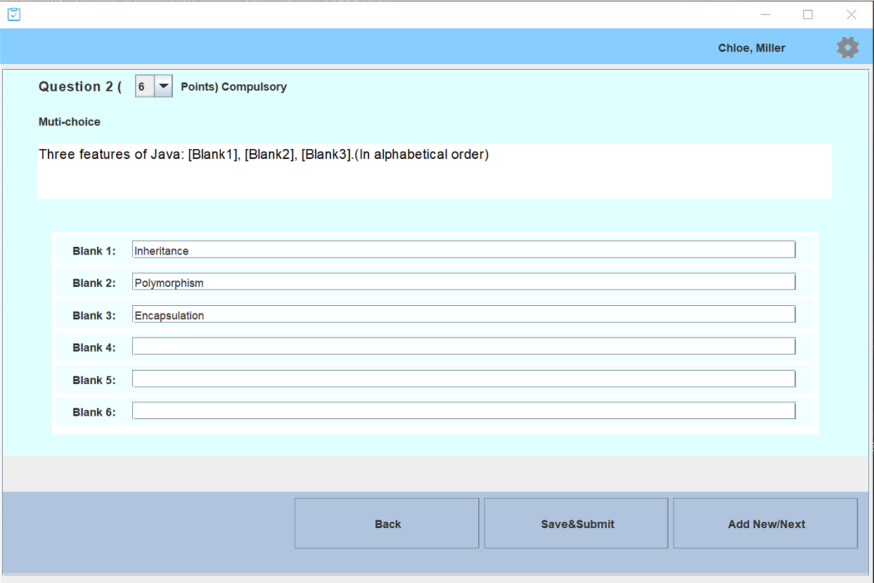

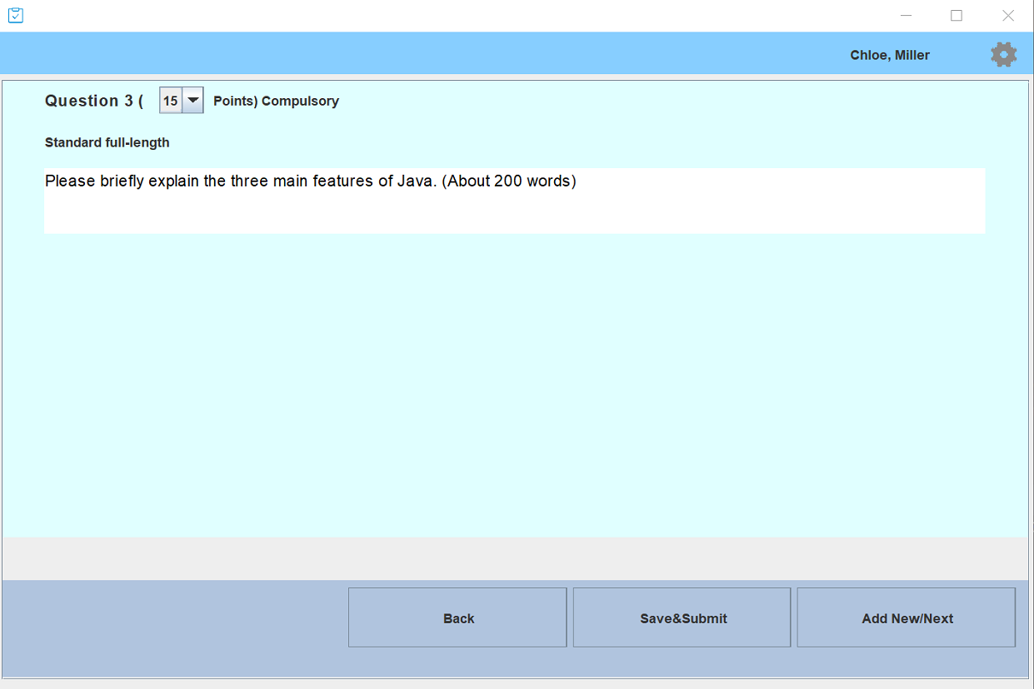

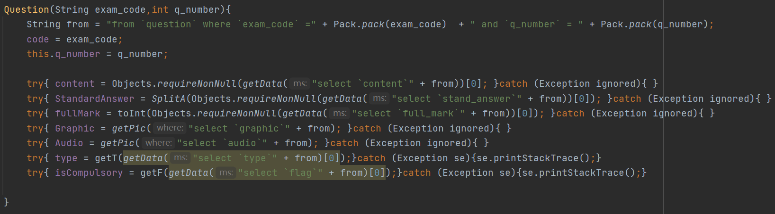

Each question must be given a score and flagged as compulsory / optional.

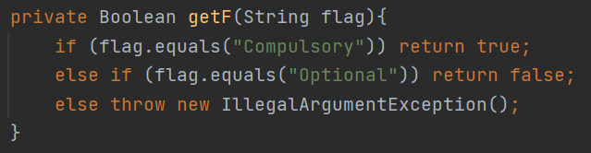

* 1. Test Taker

After a student logging on to the system, he/she is notified of any exam that will be coming up during the examination period.

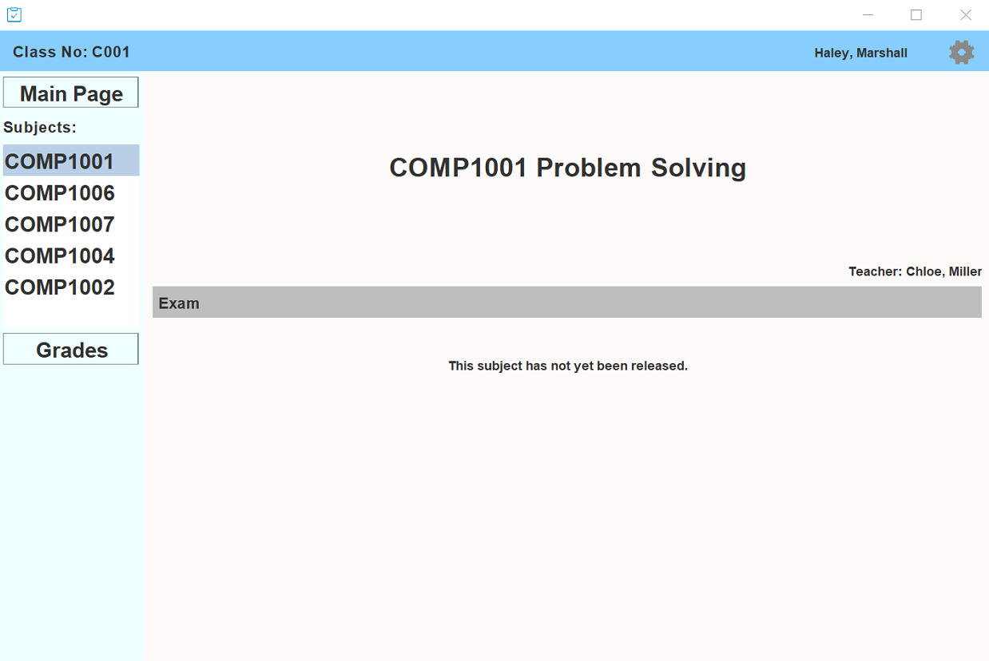

If there is an exam scheduled on that date, for the class which the student belongs the student is allowed access to the exam.

Student can press the begin button to enter the test and start answering. After finished, the student can press submit to end the test.

* 1. Test Results

The results are stored in memory and when the class test is finished, the multiple choice and fill-in-the-blanks questions are graded automatically. When finding that student entered nothing as the answer, the system will automatically set the grade of that question to 0.

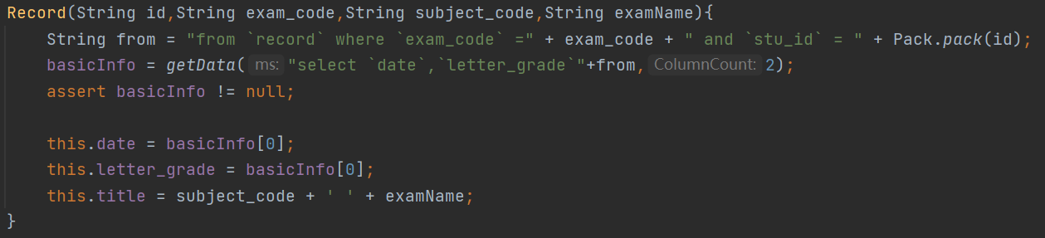

The teacher then records results for manually corrected questions.

The student’s results are then available for the student to see through the system by just press the Grades button under subject.

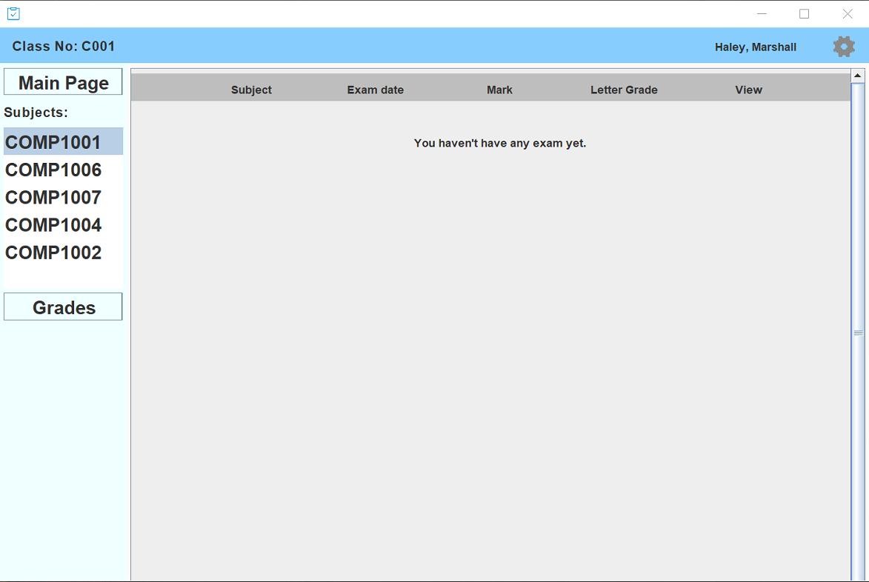

## User Guide

Welcome to the Automated Examination System. This is an intelligent system for student and teacher to take or design exams. We are going to teach you how to use step by step.

## 3.1 Login page

Students and teachers can easily log in to the system using their id and password (teachers have two modes: Class teacher and normal teacher).



Additionally, by clicking the setting button in the upper right corner, user can change the password of the current login id or sign out from the system.



## 3.2 Search information

After entering the right id and password, you will see the main page.

**For teacher:**

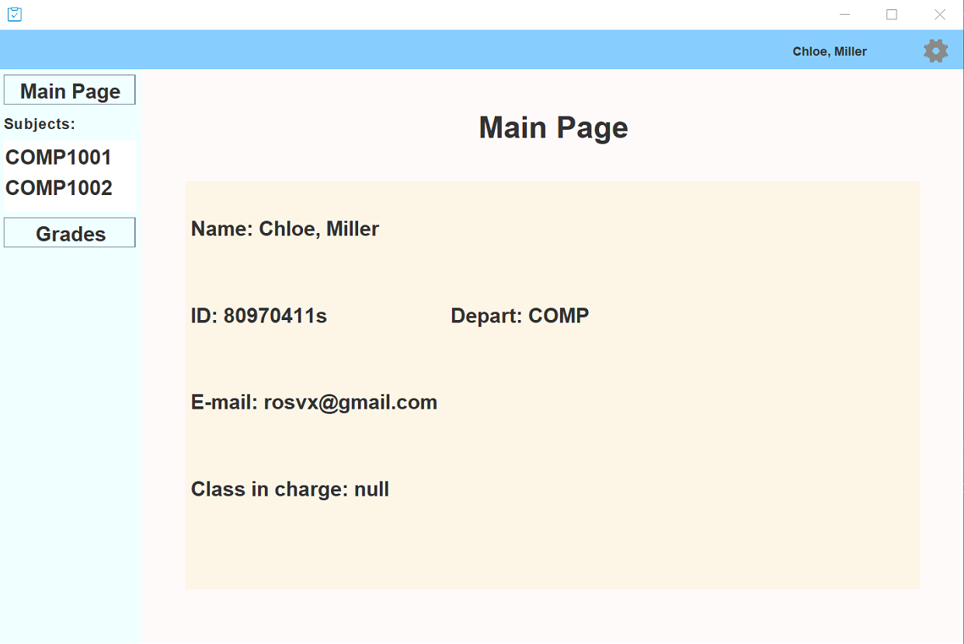

Teacher can press the class ids on the left side to see if there are exams or create exams.

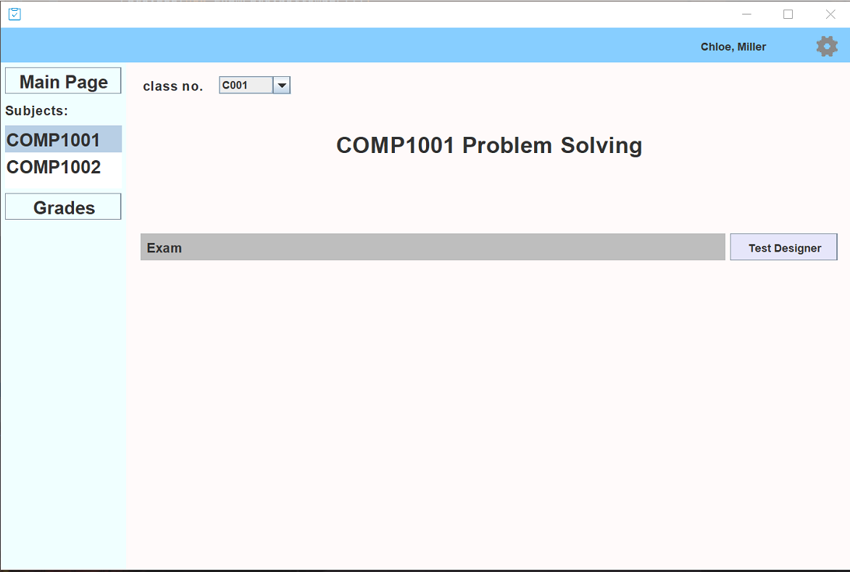

When pressing the Grades button, teacher can know the grades of all students taking this subject. For class teachers, they can also know the grades situation of all students in his/her class.

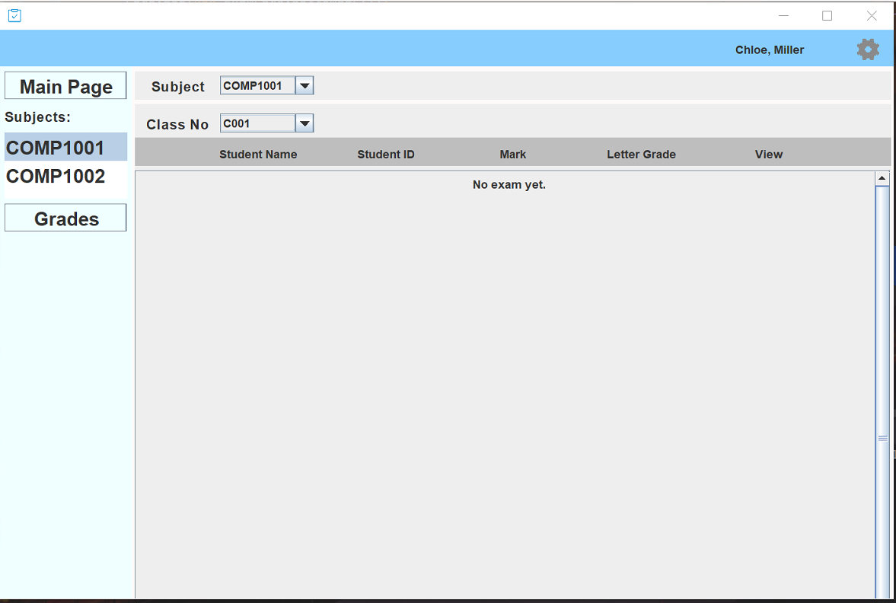

**For student:**

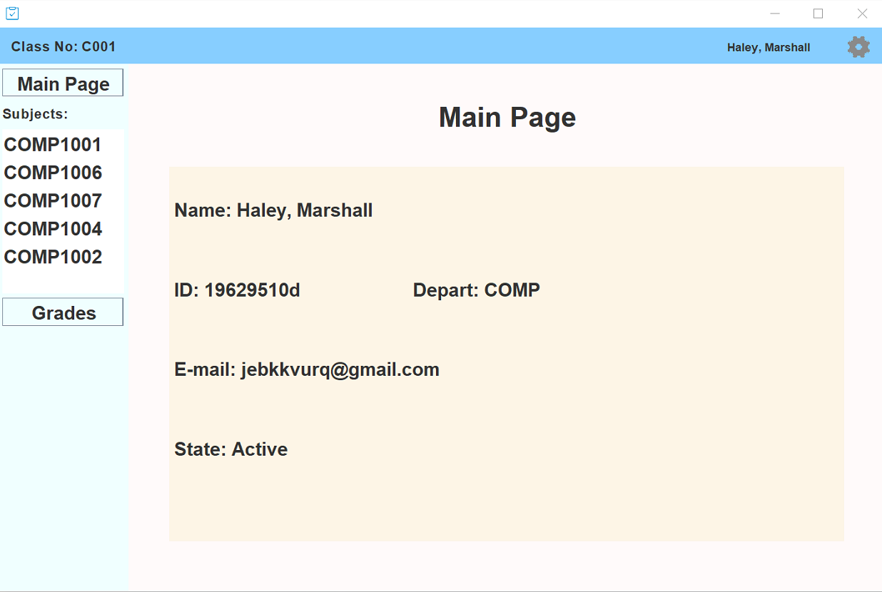

Students can press the subject id on the left side to see whether there are upcoming exams or taken exams.

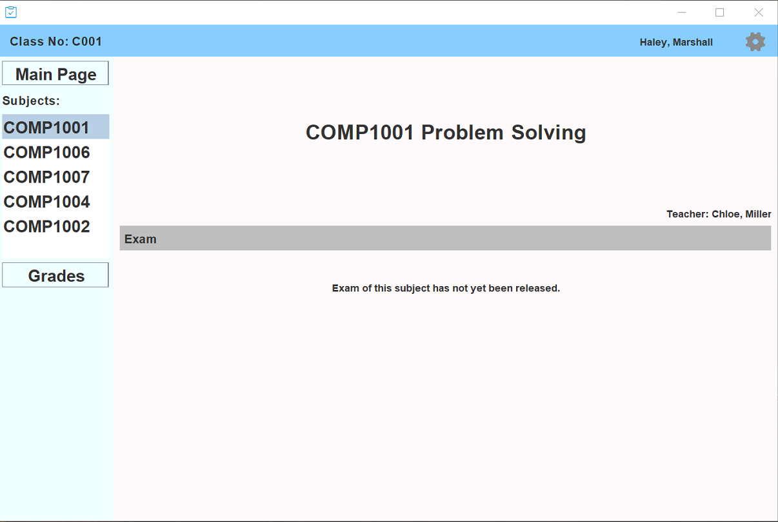

He / She can press the Grades button to see his / her grade of a certain subject.



## 3.3 Exam

For students who take exam.

When students find their upcoming exams, he / she can press the final exam on the exact date and time to begin testing.

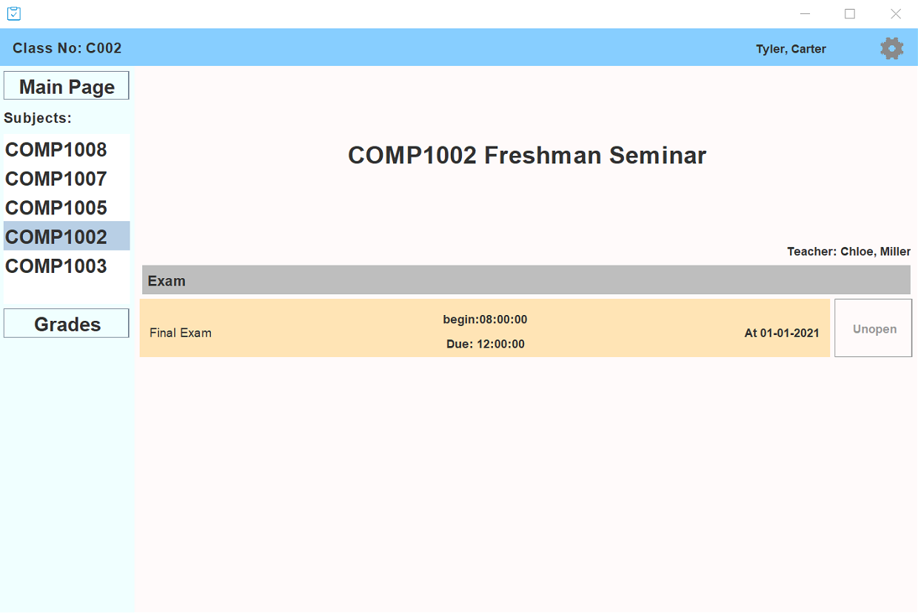

For teachers who design exam.

After teacher has signed in the exam, he/she can press the test designer button to create an exam. For each exam, teacher must enter the class name, the subject name, test number, the date, start-time and duration of the exam.



Then press enter to design the questions. For each question, it must be given a score and flagged as compulsory / optional. The teacher should also enter the question and the correct answers (excluding the standard exam type questions which will be corrected manually on-screen in a batch).





Once finishes one question, press add new / next to go on.





When the exam designing is done, the page will show:

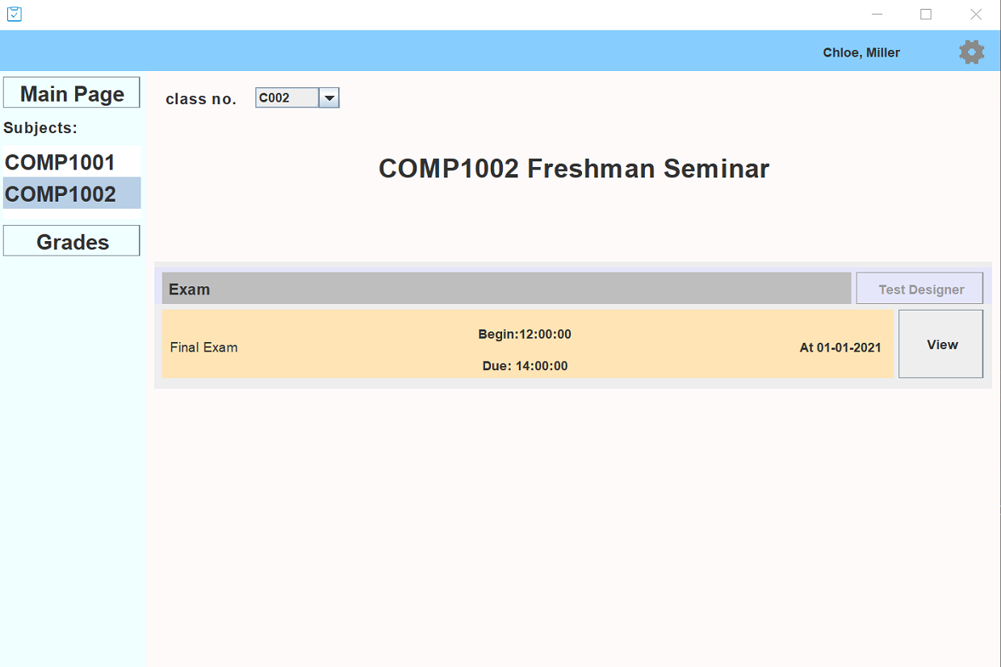

Finally, press save & submit and the test will be saved for certain students to take.

## 3.4 Grade

Teacher

Student

Student can press the Grades button to see his / her grade of a certain subject.



## 3.5 Report

In grade page, student will see all the test result of his subjects. Details about exam data, letter grade and so on.

If the student haven’t take any exams, he will see the prompt like this.

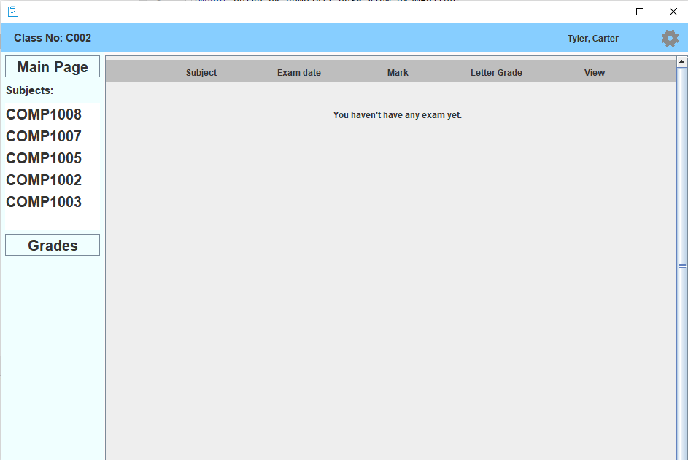

Teacher users will see the grade details of all the students in the class he/she taught.

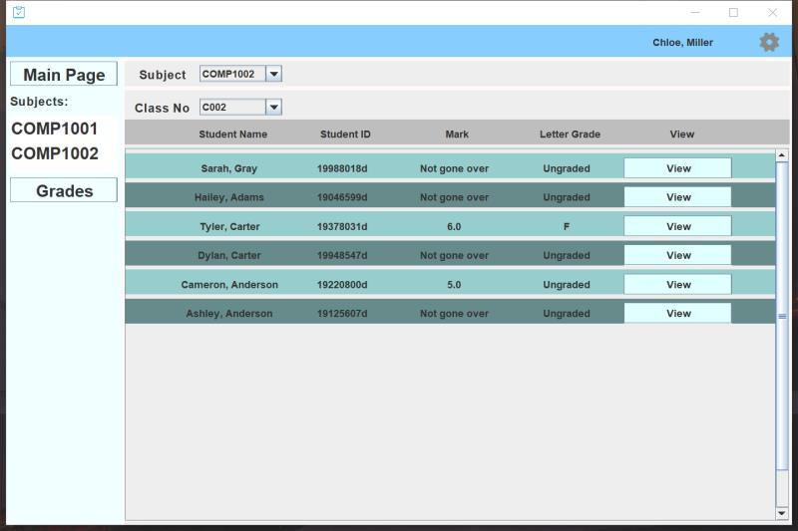

## Contribution List

|  |  |
| --- | --- |
| Name | Contribution |
| Pan Zewen  (19083967d) | Write part of the report, build presentation ppt and part of codes. |
| Tian Ruijie  (19079692d) | Finishing part of code and the report. |
| Wang Xiangzhi  (19082878d) | Finishing most part of codes. Writing part of report. Design ER diagram and schema. |
| Wang Zhe  (19080037d) | Write part of the report. Design the ER Diagram and the Relational Schema. |
| Zhang Xianyi  (19078513d) | Doing the model part of the codes. Write most part of the report. Editing presentation vadio. |